**Predicting Co2 Emission In Vehicles**

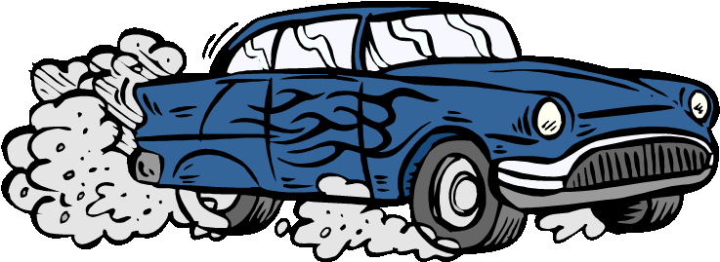

**Yash G Anghan**

**INDEX**

1. INTRODUCTION
   1. OVERVIEW
   2. PURPOSE
2. LITERATURE SURVEY
   1. Existing Problem
   2. Proposed solution
3. THEORITICAL ANALYISIS
   1. Block Diagram
   2. Hardware/Software Designing
4. EXPERIMENTAL INVESTIGATION
5. FLOWCHART
6. RESULT
7. ADVANTAGES AND DISADVANTAGES
8. APPLICATIONS
9. CONCLUSION

10. FUTURE SCOPE

**INTRODUCTION TO PROJECT**

Climate change has become a prominent topic in modern human civilization as it poses a threat to future generations of human kind. Researchers from different parts of the globe have conducted research concerning climate change and some of the effects predicted are being experienced such as extreme weather conditions. Droughts, storms and extreme heat are leading headlines on news platforms. These conditions call upon researchers and policymakers to provide guidelines of sustaining the planet for the benefit of future generations. For solutions providing sustainability to be effective, the main factors contributing to climate change must be identified. Research has shown that the main contributing factors to limited change are greenhouse gases and carbon dioxide (CO2) is the main greenhouse gas contributing to climate change . The Intergovernmental Panel on Climate Change IPCC has projected a continuous rise in CO2 emissions up to the year 2050. Further research, provides evidence that 80% of total CO2 emissions globally come from fossil fuel combustion . The sectors of society were fossil fuels are used can be analyzed to monitor trends among the various sectors and their total contribution to CO2 emissions. Effectiveness of existing policies in reducing the carbon footprint can be evaluated and new policies can be suggested.

Significantly reducing CO2 emissions from cars will not be easy, but the available data can be used to extract the features, know the behavior of cars, and try to reduce the emissions

**LITERATURE SURVEY**

The amount of CO2 emission from the transport sector (including cars) accounts for about 20% of total CO2 emissions. Accordingly, from the viewpoint of preventing global warming, reducing that proportion is a key issue. In regard to CO2 emissions from cars, fuel economy standards are getting tougher all over the world, so improving the fuel economy of cars is strongly desired. From now onwards, it is considered that the fuel economy of engines will be further improved by boosting engine efficiency and by hybridization (electrification) of cars. What’s more, improving fuel economy by improving “driving operation” (i.e. the operation in which a car is driven) and by smoothing traffic flows will come into the picture in the near future. Under these circumstances, with concern for the environment from the viewpoint of reducing CO2 and other exhaust emissions, the Hitachi Group is comprehensively promoting a broad range of technical developments for reducing CO2 emissions from cars.

Significantly reducing CO2 emissions from cars will not be easy, but the available data can be used to extract the features, know the behavior of cars, and try to reduce the emissions. Machine Learning techniques can be used in this regard.

**THEORITICAL ANALYSIS**

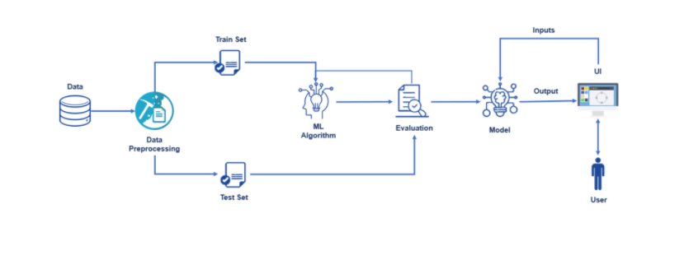

* Hardware and Software designing:

Anaconda Navigator: Anaconda Navigator is a desktop graphical user interface (GUI) included in Anaconda distribution that allows you to launch applications and easily manage conda packages, environments, and channels without using command-line commands. Navigator can search for packages in a local Anaconda Repository. It is available for Windows, macOS, and Linux.

Flask : Flask is a micro web framework written in Python which is used to build web applications.

**EXPERIMENTAL INVESTIGATION**

There are several Machine learning algorithms to be used depending on the data you are going to process such as images, sound, text, and numerical values. The algorithms can be chosen according to the objective. As the dataset which we are using is a Regression dataset so you can use the following algorithms

* Multi Linear Regression
* Random Forest Regression / Classification
* Decision Tree Regression / Classification
* K-Nearest Neighbors
* Support Vector Machine

The model which has been used here is linear regression.

Linear regression is used when the dependent and independent variables are linearly associated. Once the model is trained, it’s ready to make predictions. We can use the **predict method** on the model and pass **x_test** as a parameter to get the output as **y_pred** Notice that the prediction output is an array of real numbers corresponding to the input array.

**FLOW CHART**

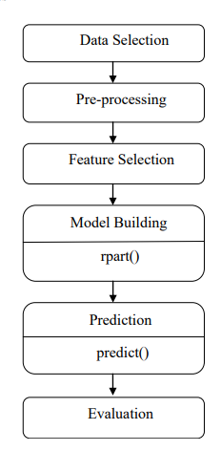

**ADVANTAGES AND DISADVANTAGES**

* Advantages
* One of the main advantage is that the prediction is going to be done by the help oh machine learning and that will give you the most accurate outcome. It also reduces the man force for performing experiments to find the solutions to the problems.
* It is also budget friendly as it is less expensive.
* Disadvantages:
* There is possibility that the outcome will not be predicted in the right way and it would not be exactly approximate and that could be troublesome.

**APPLICATIONS**

* Person need to interact with user interface to enter appropriate data
* Entered data will analyzed by the model which is inbuilt.
* Ones the model analyses the given data the prediction is show on portal
* By using this web portal user can understand how many co2 generate by their cars so they can do service on time.

.

**RESULT AND CONCLUSION**

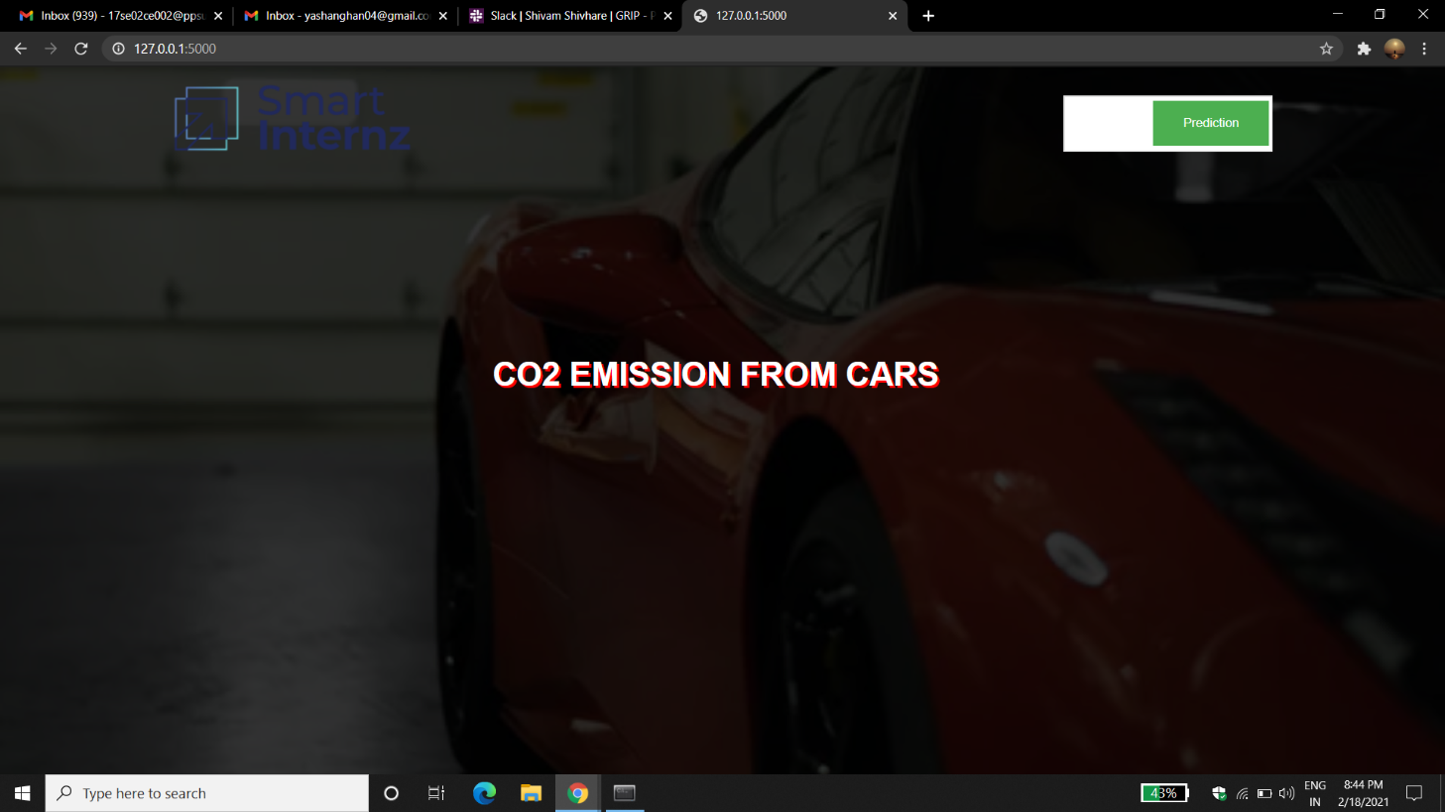

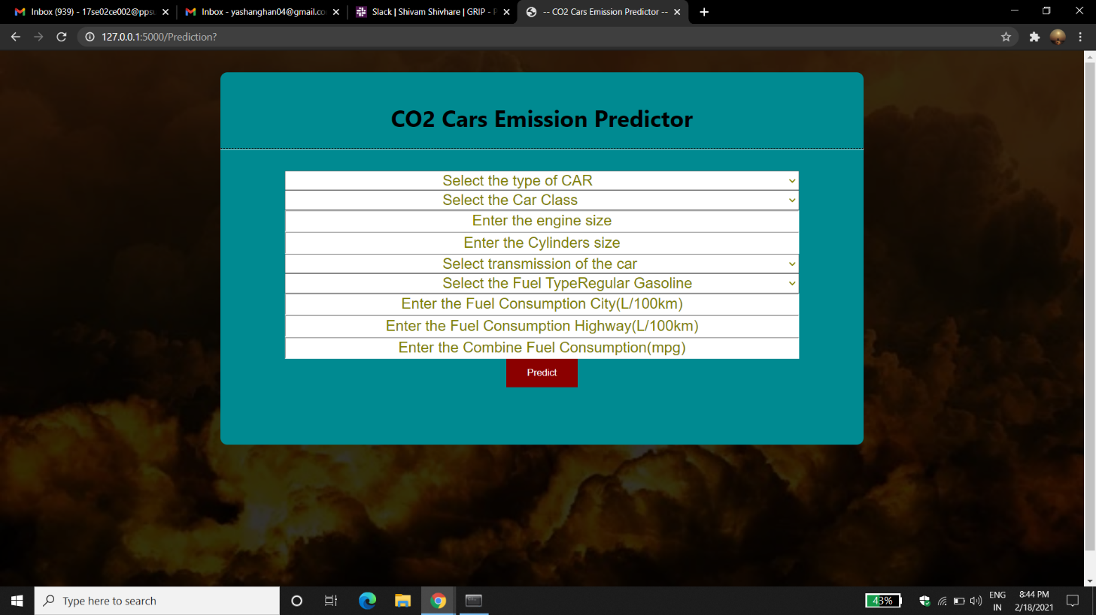

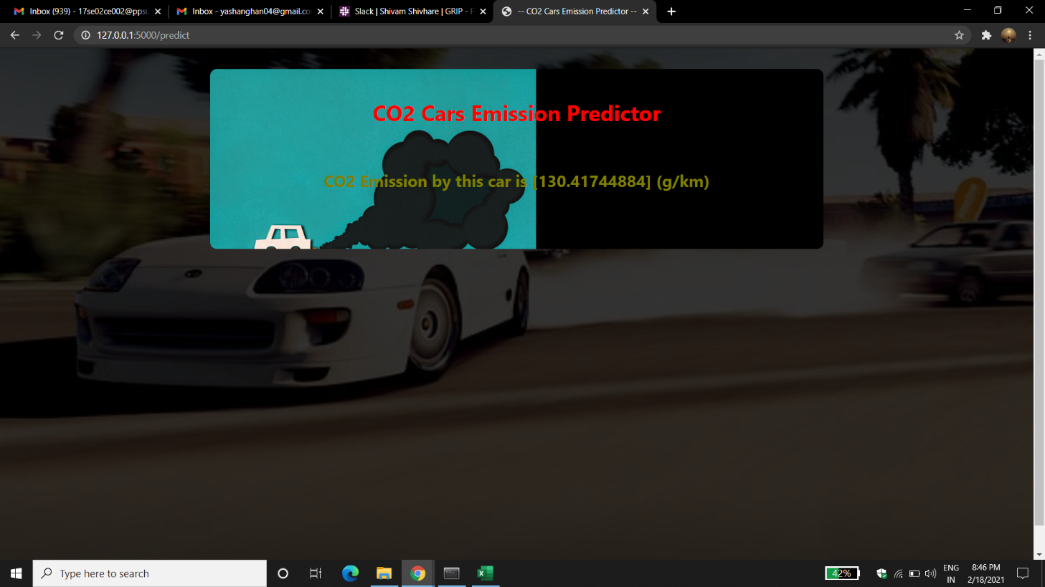

* I am able to understand the problem to classify if it is a regression or a classification kind of problem.
* I was able to know how to pre-process/clean the data using different data pre-processing techniques.
* I was able to analyze or get insights into data through visualization.
* I was able to know how to find the accuracy of the model
* I was also be able to build web applications using the Flask framework.

**FUTURE SCOPE**

By using machine learning the system can be made more proficient in predicting performance. Web applications which have been made using flask can be improved in order to make it more user-friendly. As a result, people would use the web-application more and get the value of co2 which is generated by their cars Apart from this, the features which have been considered while making a prediction can be enlarged so that the accuracy level would boost-up.

**Video link:**

[**https://drive.google.com/file/d/1fVKiY2H5hH130SWKL5HjCoPgsy0kB1iO/view?usp=sharing**](https://drive.google.com/file/d/1fVKiY2H5hH130SWKL5HjCoPgsy0kB1iO/view?usp=sharing)